Batch:___B2_____ Roll No.:____1611103__
Experiment No. 10
Grade: AA / AB / BB / BC / CC / CD /DD

Title: Implementation of Graph menu driven program for DFS and BFS.

Objective:

Expected Outcome of Experiment:

CO | Outcome
1 | Explain the different data structures used in problem solving.

Books/ Journals/ Websites referred:

1. Data Structures A Psedocode Approach with C, Richard F. Gilberg & Behrouz
A. Forouzan, second edition, CENGAGE learning.
2. C & Data Structures By O. G. Kakde

Abstract:-
A graph is a structure made of two components: a set of vertices V, and a set of edges
E. Therefore, a graph is G = (V,E), where G is a graph. The graph may be directed or
undirected. In a directed graph, every edge of the graph is an ordered pair of vertices
connected by the edge, whereas in an undirected graph, every edge is an unordered pair
of vertices connected by the edge.
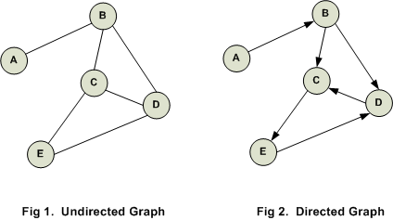

Directed edge: A directed edge between the vertices vi and vj is an ordered pair. It is
denoted by <vi,vj>.

Undirected edge: An undirected edge between the vertices vi and vj is an unordered
pair. It is denoted by (vi,vj).

Types of Graph:
-Simple graph
-Undirected or directed graphs
-Cyclic or acyclic graphs
-Labeled graphs
-Weighted graphs
-Infinite graphs

Representation of a Graph in Memory:

Adjacency Matrix:
Adjacency Matrix is a 2D array of size V x V where V is the number of vertices in a graph. Let the 2D array be adj[][], a slot adj[i][j] = 1 indicates that there is an edge from vertex i to vertex j. Adjacency matrix for undirected graph is always symmetric. Adjacency Matrix is also used to represent weighted graphs. If adj[i][j] = w, then there is an edge from vertex i to vertex j with weight w.
The adjacency matrix for the above example graph is:
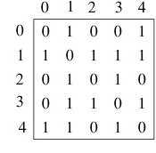
Pros: Representation is easier to implement and follow. Removing an edge takes O(1) time. Queries like whether there is an edge from vertex ‘u’ to vertex ‘v’ are efficient and can be done O(1).
Cons: Consumes more space O(V^2). Even if the graph is sparse(contains less number of edges), it consumes the same space. Adding a vertex is O(V^2) time.
Adjacency List:
An array of linked lists is used. Size of the array is equal to number of vertices. Let the array be array[]. An entry array[i] represents the linked list of vertices adjacent to the ith vertex. This representation can also be used to represent a weighted graph. The weights of edges can be stored in nodes of linked lists. Following is adjacency list representation of the above graph.

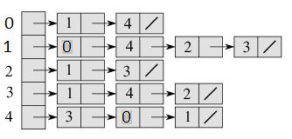

Pros: Saves space O(|V|+|E|) . In the worst case, there can be C(V, 2) number of edges in a graph thus consuming O(V^2) space. Adding a vertex is easier.
Cons: Queries like whether there is an edge from vertex u to vertex v are not efficient and can be done O(V).
Implementation:-
#include<iostream.h>
#include<conio.h>
#include<stdlib.h>
#define MAX 100
typedef struct Vertex
{
int data;
Vertex *NextVertex;
};
void QInsert(Vertex *q[],int *f,int *r,Vertex *data)
{
if(*r == MAX - 1)
return;
q[++(*r)] = data;
if((*f) == -1)
*f = 0;
return;
}
Vertex *QDelete(Vertex *q[],int *f,int *r)
{
if(*f == -1)
return NULL;
else if(*f == *r)
{
int temp = *f;
*f = *r = -1;
return q[temp];
}
else
return q[(*f)++];
}
void AddVertex(Vertex *head,int d)
{
Vertex *temp = head;
while(temp->NextVertex!=NULL)
temp = temp->NextVertex;
temp->NextVertex = (Vertex *)malloc(sizeof(Vertex));
temp = temp->NextVertex;
temp->data = d;
temp->NextVertex = NULL;
}
void dfs(Vertex *head[],int visited[],int value)
{
cout<<head[value]->data<<"\t";visited[value] = 1;
Vertex *temp = head[value]->NextVertex;
while(temp!=NULL)
{
if(visited[temp->data] == 0)
dfs(head,visited,temp->data);
temp = temp->NextVertex;
}
}
void bfs(Vertex *head[],int visited[],int value)
{
Vertex *temp,*Queue[MAX];
int front = -1,rear = -1;
QInsert(Queue,&front,&rear,head[value]);
while(front != -1 && rear != -1)
{
temp = head[QDelete(Queue,&front,&rear)->data];
while(temp!=NULL)
{
if(visited[temp->data] == 0)
{
cout<<temp->data<<"\t";
visited[value] = 1;
QInsert(Queue,&front,&rear,temp->NextVertex);
}
temp = temp->NextVertex;
value = temp->data;
}//end of inner while
}
}
int main()
{
clrscr();
int TotalVertices,TotalAdjNodes,visited[MAX],value,NodeValue;
Vertex *head[MAX];
cout<<"Enter the total no. of vertices in the graph :- ";
cin>>TotalVertices;
for(int i = 0;i<TotalVertices;i++)
{
cout<<"Enter the vertex:- ";
cin>>value;
//AddVertex(head[i],value);
head[value] = (Vertex *)malloc(sizeof(Vertex));
head[value]->data = value;
head[value]->NextVertex = NULL;
visited[value] = 0;
cout<<"Enter the total adjacent vertices of \""<<head[value]->data<<"\" : ";
cin>>TotalAdjNodes;
for(int j = 0;j<TotalAdjNodes;j++)
{
cout<<"Enter the adjacent node:- ";
cin>>NodeValue;
AddVertex(head[value],NodeValue);
}
}
int opt;
cout<<"Enter the traversal:- \n";
cout<<"1.DFS Traversal.\n2.BFS Traversal.\n3.Exit.\n";
cin>>opt;
switch(opt)
{
case 1:
cout<<"Enter the start for DFS traversal:- ";
cin>>value;
cout<<"DFS Traversal :- \n";
dfs(head,visited,value);
cout<<endl;
for(i = 0;i<MAX;i++)
visited[i] = 0;
break;
case 2:
cout<<"Enter the start for BFS traversal:- ";
cin>>value;
cout<<"\nBFS Traversal :- \n";
bfs(head,visited,value);
cout<<endl;
for(i = 0;i<MAX;i++)
visited[i] = 0;
break;
case 3:break;
default:
cout<<"Illeagal value entered.\nTerminating the program......\n.";
getch();
return 0;
}
cout<<"Thank You.Visit Again!!!\n";
getch();
return 0;
}
Output:

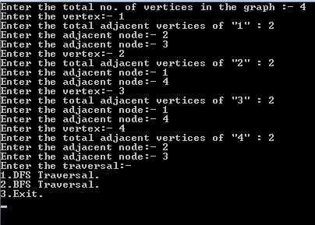

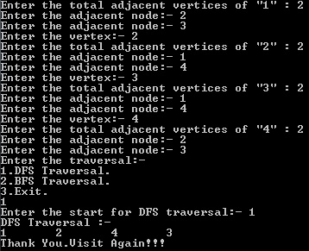

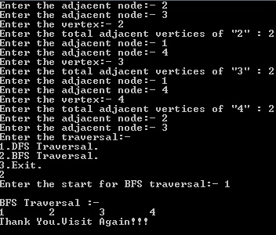

Conclusion:- The program has been executed in C and the output has been verified.

Post Lab Questions:-

1) Enlist all steps followed and various options explored.
Ans:
- The following graph was made using Adjacency list.
- Its traversal is done using queue (for BFS) and recursive function, i.e., stack (for DFS).
- User is given an option between two traversals.
- The given traversal is then printed on the screen.

2) Explain your program logic, classes and methods used.
Ans:
- Void dfs:-
Prints the depth first traversal of the graph.
- Void bfs:-
Prints the breadth first traversal of the graph.
- Struct vertex:-
The structure of vertices of the graph.
- Void QInsert:-
Inserts element in queue
- Vertex *QDelete:-
Deletes an element from the queue.
- Void AddVertex:-
Adds a vertex in the head passed.
3) Explain the Importance of the approach followed by you.

Ans:

In the approach followed I have used adjacency list. This saves memory as we are not saving info of vertices that are not linked to that vertex.

Conclusion:-

